# 索引

## 普通索引

@Table(name = **"kun_api_permit_param"**,  
 indexes = { @Index(columnList = **"team_id"**) })

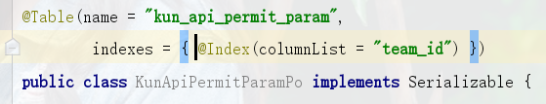

## 唯一索引

@Table(name = **"kun_api_app_manage"**, uniqueConstraints = @UniqueConstraint(columnNames = {**"app_key"**}))

